Daily Tip 62 26/08/2003 09:38:00 PM

Displaying all characters of a SAS font
You can use the GFONT procedure to display the characters from one of the SAS supplied fonts that come with SAS/Graph. This can be useful for fonts which have special characters, so that you can see what characters you must specify in order to get the special characters.
The following is a macro which will make a chart containing a list of all characters within a font. The chart is saved into a graphic file. You can then look at the chart to look up characters you want to use.

SAS Program
%macro showfont(font) ;
filename font "c:\&font..png" ;
goptions reset=all device=png gsfname=font ;
title "Font: &font" ;
proc gfont name=&font
nobuild
height=.4 cm
romcol=red
romfont=swissl
romht=.3 cm
showroman ;
run;
quit;
%mend showfont ;

%showfont(math)
%showfont(greek)

Charts produced

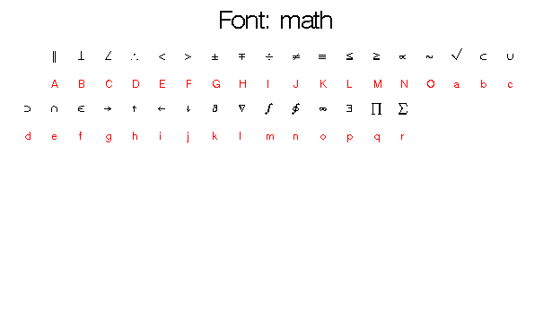

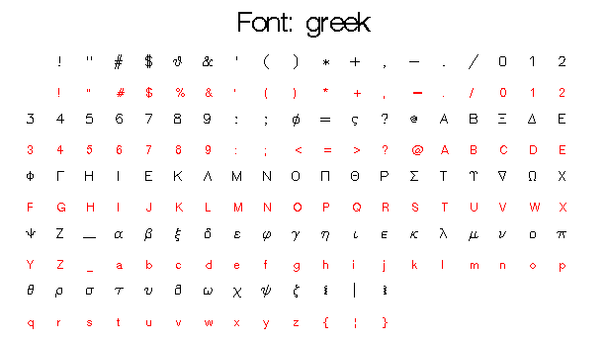
Example tested under SAS 8.2, Windows 2000 by Phil Mason
Wood Street Consultants Ltd. tips@woodstreet.org.uk
www.woodstreet.org.uk
Instant Messengers … ICQ:27165944, AOL:philipamason, MSN: philipandrewmason@hotmail.com, Yahoo: philipandrewmason

Remember: I am offering 3 courses at NESUG next week – to register go to www.nesug.org

